SACHDEVA COLLEGE OF PHARMACY, GHARUAN

JANAMASHTAMI CELEBRATION -2025
India the land of God and Goddesses, the land of its rich culture and tradition always enjoys celebrating every moment with great joy and happiness. Taking this thing into account, Sachdeva college of Pharmacy, Gharuan celebrated Janamashtami on 18th of Aug 2025 to pay obeisance to Lord Krishna the eighth incarnation of Lord Vishnu. So this day marked as the birth day of the God and students celebrated this day in the honour of Lord Krishna. The celebration commenced with an Arti and prayers, creating a spiritual atmosphere, with the event offering sweet Butter called Makhan Prashad to Lord Krishna. Here, students also decorated Lord Krishna Swing called Jhoola for the spiritual rituals to be performed on that day. Students showcased their talents through various cultural programs like singing Devotional Songs and Traditional Dances. The campus was decorated with colourful Rangolis and banners, and students created artistic representations of the festival, such as making flutes or decorating earthen pots. A highlight of the celebration was the Dahi Handi competition, where students formed teams to build human pyramids to break a pot filled with curd, fostering a spirit of teamwork and excitement. College faculty and administration also participated in the events, showing support and encouraging student involvement, with some expressing pride in the students' efforts. On this auspicious day, College also welcomed BK Aditi Behan and BK Shivani from Prajapita Brahma Kumaris Ishwariye Vishwa Vidyalaya, Mohali who delivered their lecture on the topics Relax, Recharge and Rejuvenate and on Drug De-addiction. They also taught how to meditate and feel Godly presence in the Universe. The event concluded with the distribution of Prashaad and a vote of thanks from Principal Prof. Dr. V.K. Gupta to all participants, creating a sense of shared joy and blessings.
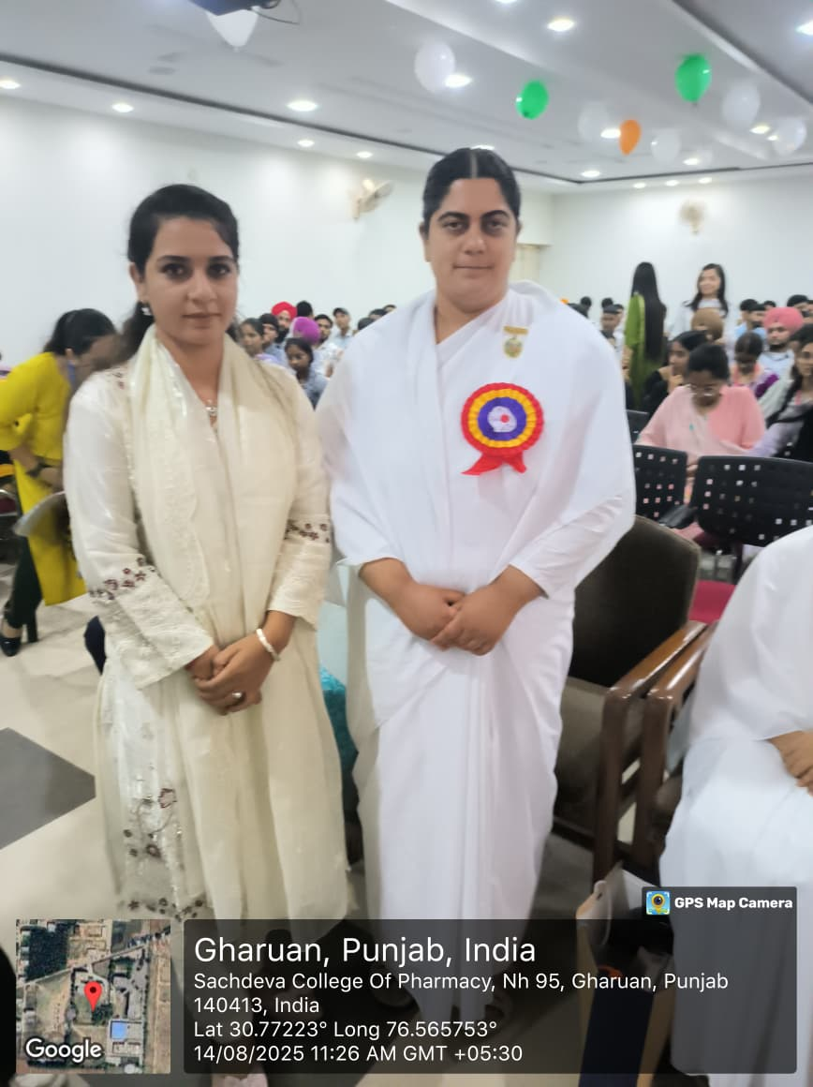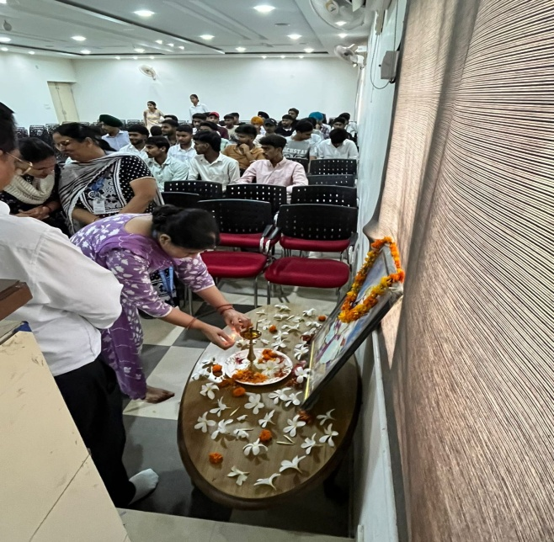
Mr. Rajpal Singh Delivering Lecture to the Faculty

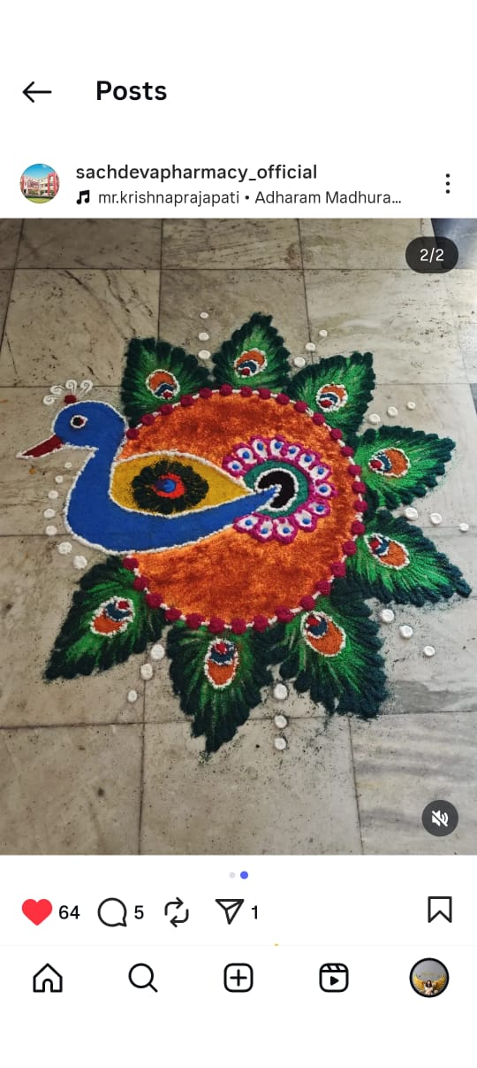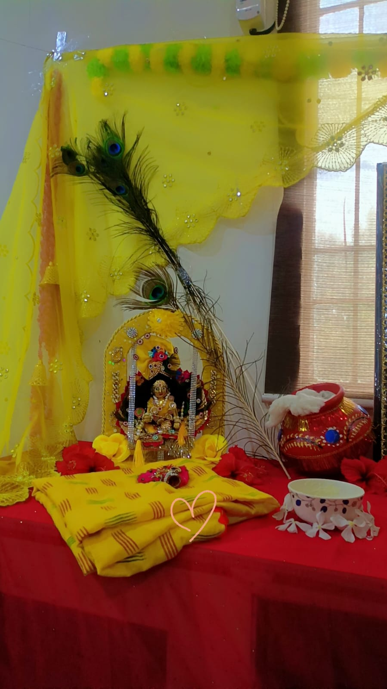

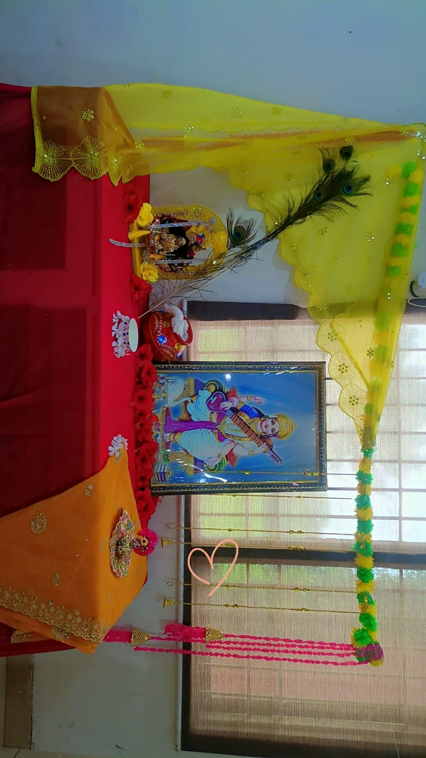

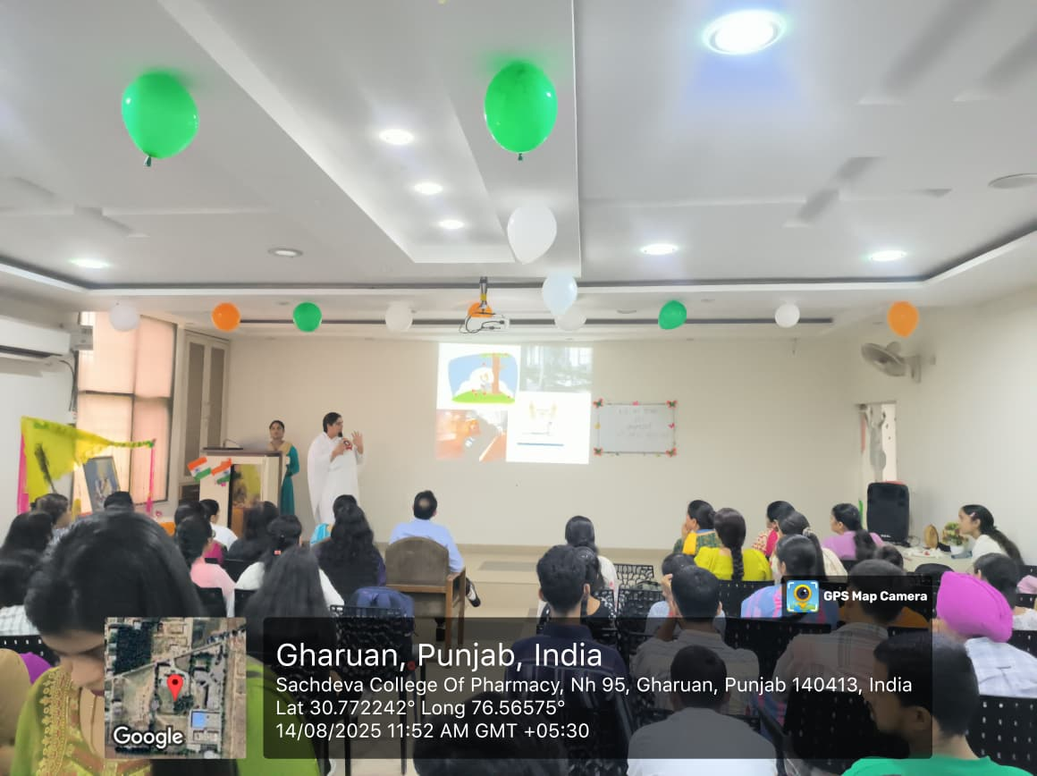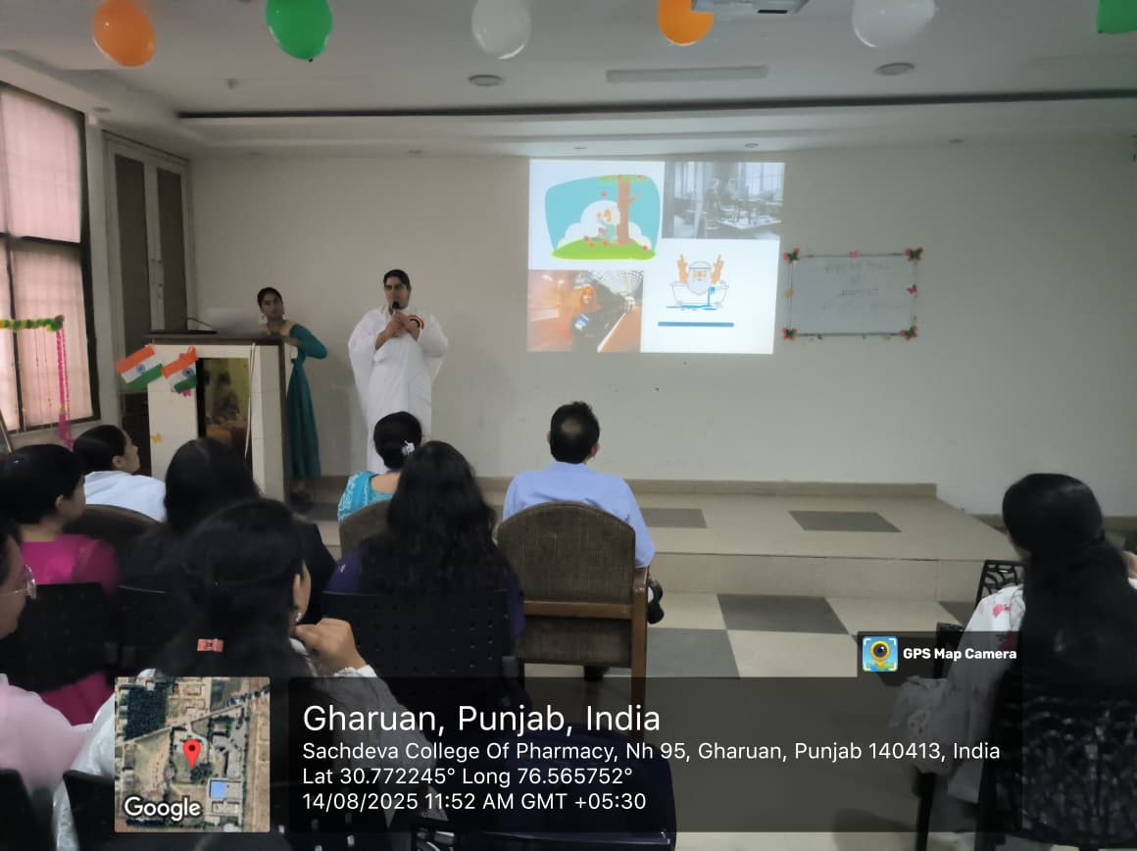
Faculty attending Lecture along with HOD

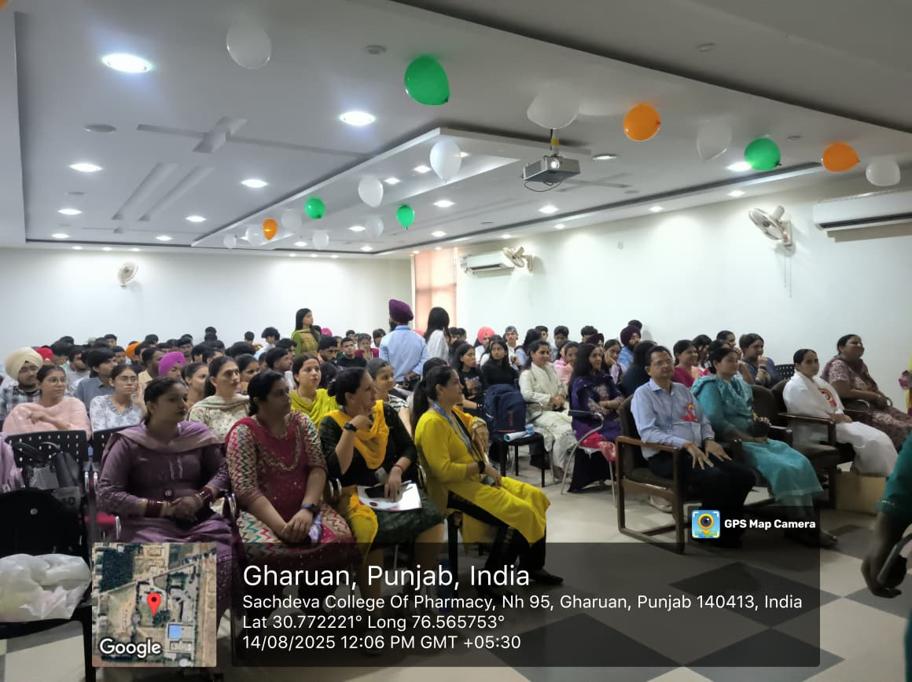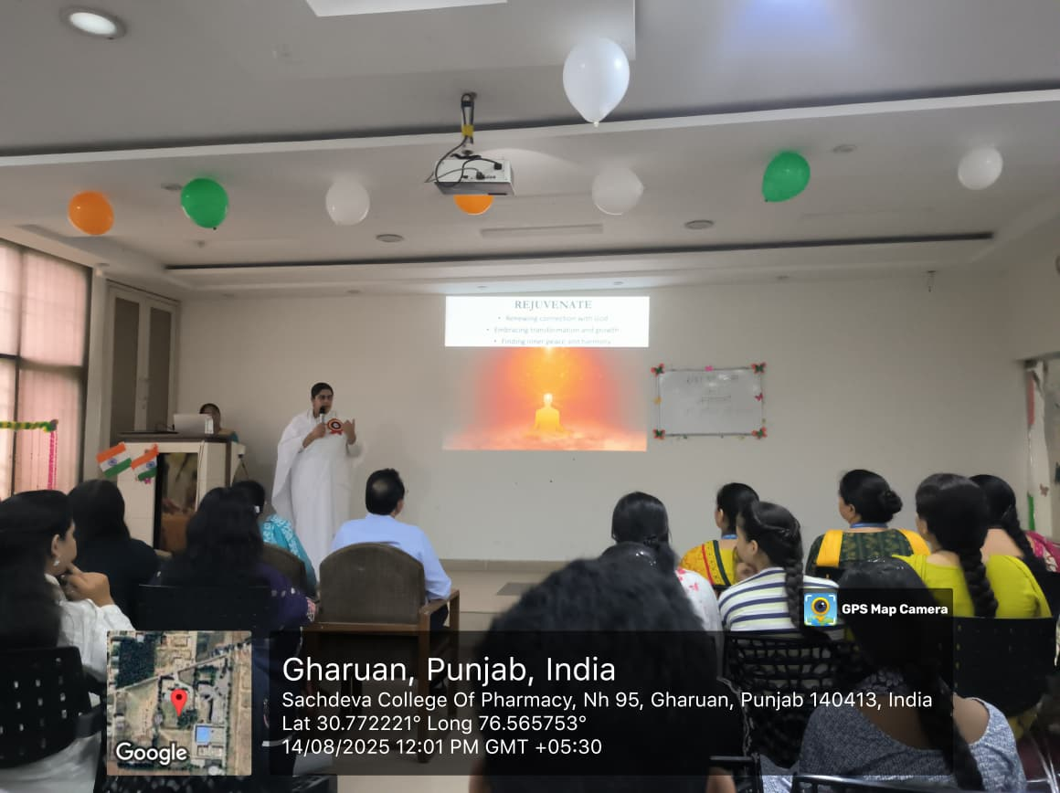
Vote of Thanks by Principal Sir
